Build Maven Project

Install maven integration plugin

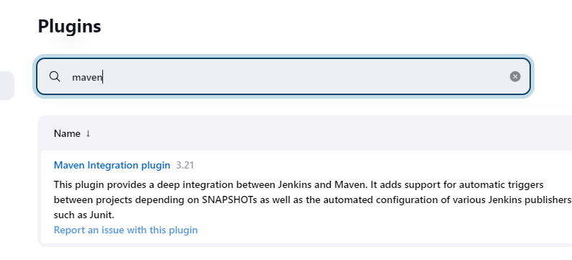

Install maven on ubuntu

sudo apt install maven -y

Manage plugin->Global Tool Configuration

Setup jdk home

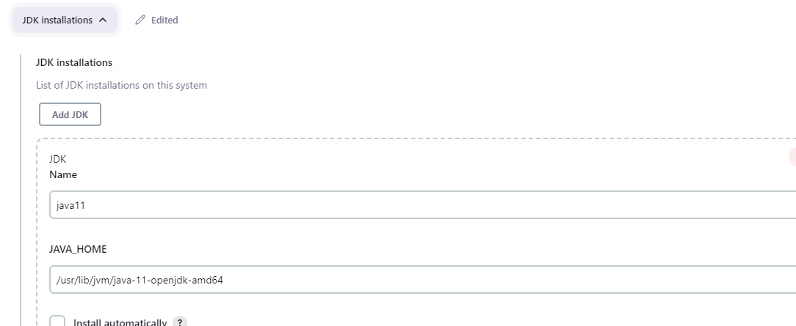

Setup maven home

Create a project and select maven project

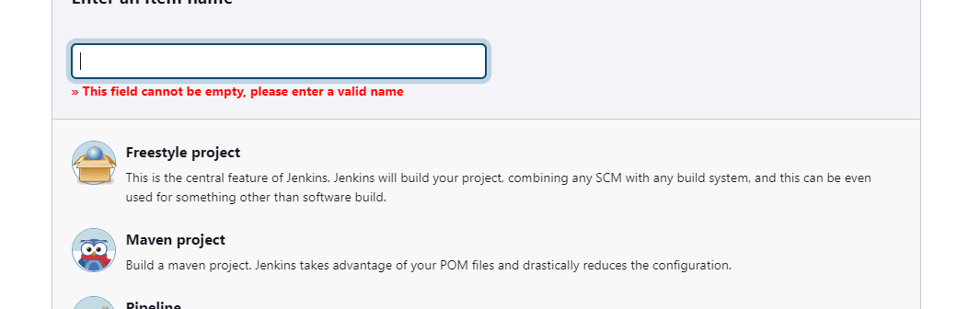

In mavenproject provide github project

https://github.com/amitvermaa93/jenkins-git-integration.git/

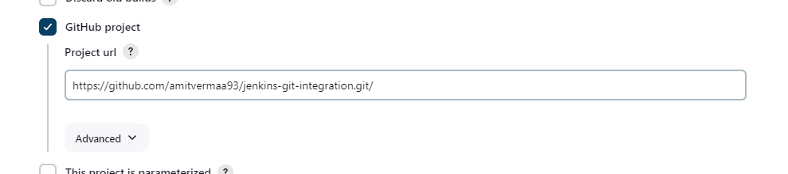

SCM git

https://github.com/amitvermaa93/jenkins-git-integration.git

